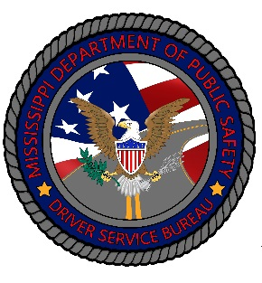

IT’S FINALLY HERE!

BRINGING SENIOR DRIVES TO THE FRONT
- Get your insurance discount. Some auto insurance companies in this state provides a multiyear discount to AARP graduates! (Consult your insurance agents). For more information
visit: www.aarp.org/drive Simply submit the approved AARP
certificate of completion to the
Jackson Driver Service Bureau/
Administrative Office at the address
below and receive your letter towards a
premium reduction.

1900 East Woodrow Wilson Drive. Jackson, MS 39216
DPS OR THE DRIVER SERVICE BUREAU DO NOT GARENTEE ACCEPTANCE BY ANY PARTICULAR INSURANCE COMPANY

